Deepfake Image Detection Using Convolutional Neural Networks: A Comparative Analysis of Custom CNN Architectures for Binary Image Classification

Abstract
The use of deepfake images created with sophisticated Artificial Intelligence (AI) methods has emerged as a major threat to digital security, online trust and cybersecurity. Transfer learning-based deep learning systems have achieved high detection accuracy, but consume significant computational resources and are not easily deployable in a lightweight application. This project aims to overcome this by designing, developing and comparatively testing three custom Convolutional Neural Network (CNN) architectures that have been built from scratch for the binary classification of deepfake and real images. The Hugging Face Hub's publicly available dataset was used and images were preprocessed, explored, normalised, and augmented before training the models.
The three CNN architectures were implemented in TensorFlow and Keras, and the accuracy, precision, recall, F1-score, confusion matrix, ROC-AUC, and training time were used to evaluate the models under the same experimental conditions. Experimental results showed that the performance of the deeper CNN architectures was inferior to Model 1 (Baseline CNN) with a test accuracy of 74.50%, precision of 69.22%, recall of 86.20%, F1-score of 76.78% and an AUC of 0.834. The results show that effective deepfake image detection can be achieved by designing a simple and lightweight CNN model without using complex transfer learning models. This study helps in the evolution of scalable, effective, and usable AI-based deepfake detection tools for cybersecurity, digital forensics, journalism, and online content authentication.

Table of Contents
Chapter 1: Problem Definition and Research Focus 4
1.1 Background and Problem Definition 4
1.2 Research Aim 4
1.3 Research Objectives 5
1.4 Research Questions 5
1.5 Significance of the Research 5
Chapter 2: Literature Review 6
2.1 Overview 6
2.2 Deepfake Image Generation and Detection: Challenges and Current Research 6
2.3 Deep Learning and Convolutional Neural Networks for Deepfake Image Classification 7
2.4 Image Pre-processing, Data Augmentation, and Exploratory Data Analysis for CNN-Based Deepfake Detection 8
2.5 Performance Evaluation and Comparative Analysis of CNN Models for Deepfake Image Detection 9
2.6 Theoretical Framework 11
2.7 Research Gap 12
Chapter 3: Research Methodology 14
3.1 Research Design 14
3.2 Data Collection 14
3.3 Data Pre-processing and Exploratory Data Analysis 14
3.4 CNN Model Development 15
3.5 Model Evaluation 15
3.6 Methodological Limitations 15
Chapter 4: Artefact Design and Development 16
4.1 Artefact Overview 16
4.2 System Design and Development 16
4.3 Tools and Technologies 16
4.4 Implementation and Testing 16
4.4.1 Dataset Inspection and Validation 16
4.4.2 Image Resizing and Training–Validation Data Preparation 17
4.4.3 Test Data Preparation and Pixel Value Inspection 18
4.4.4 Class Distribution of the Training Dataset 19
4.4.5 Sample Images of Deepfake and Real Classes 20
4.4.6 Overall Pixel Intensity Distribution 20
4.4.7 Average Deepfake and Real Images 21
4.4.8 Mean RGB Channel Values by Class 21
4.4.9 Image Brightness Distribution by Class 22
4.4.10 Class Distribution 22
4.4.11 Per-Channel Pixel Value Distribution 23
4.4.12 Data Pre-processing and Feature Engineering 23
4.4.13 Model Architecture 24
Chapter 5: Project Management 28
5.1 Project Planning 28
5.2 Project Implementation 28
5.3 Risk Management 28
5.4 Challenges and Adaptations 28
5.5 Reflection on Project Management 29
Chapter 6: Evaluation and Discussion 30
6.1 Model Outcomes 30
6.1.1 CNN Model 1: Simple Baseline CNN 30
6.1.2 CNN Model 2: Deeper CNN with Batch Normalization 31
6.1.3 CNN Model 3: Wide CNN with Global Average Pooling 33
6.2 Model Performance Comparison 34
6.3 Classification Metrics Comparison 35
6.4 Validation Accuracy Comparison across Models 35
6.5 ROC Curve Comparison 36
6.6 Best-Performing Model Selection 37
6.7 Sample Predictions Using the Best Model 37
6.8 Discussion 37
Chapter 7: Legal, ethical and social issues 39
Chapter 8: Conclusion and Recommendations 41
References 43
List of Figures
Figure 1: Theoretical Framework 12
Figure 2: Dataset Inspection 17
Figure 3: Data Preparation 18
Figure 4:Test Data Preparation and Pixel Value Inspection 19
Figure 5:Class Distribution 19
Figure 6:Sample Images 20
Figure 7: Overall Pixel Intensity Distribution 20
Figure 8:Average Deepfake and Real Images 21
Figure 9:Mean RGB Channel Values by Class 21
Figure 10:Image Brightness distribution by class 22
Figure 11:Class Distribution 23
Figure 12: Per-Channel Pixel Value Distribution 23
Figure 13: Data Pre-processing and Feature Engineering 24
Figure 14: Model 1 25
Figure 15: Model 2 26
Figure 16:Model 3 27
Figure 17: Model 1 evaluation 30
Figure 18: Model 1 31
Figure 19: Model 2 evaluation 32
Figure 20: Model 2 33
Figure 21: Model 3 evaluation 33
Figure 22: Model 3 34
Figure 23: Model Performance Comparison 35
Figure 24: Classification Metrics Comparison 35
Figure 25: Validation Accuracy Comparison 36
Figure 26: ROC Curve Comparison 36
Figure 27: Best-Performing Model 37
Figure 28: Sample Predictions 37

Chapter 1: Problem Definition and Research Focus

1.1 Background and Problem Definition
Artificial Intelligence (AI) and generative models, especially the rapid progress of deep learning, have revolutionized the production of digital media. Recent advancements in technology, including Generative Adversarial Networks (GANs) and diffusion models, have made it possible to create highly realistic and synthetic images that can sometimes be mistaken for real photographs. While these technologies can be used for many great things in entertainment, education, digital content production and healthcare, they have also led to the creation of deep fake images on a scale never seen before, which has raised serious issues of digital trust, cyber security, misinformation, identity theft, and online fraud (Morankar et al., 2025).
Many of the existing deepfake detection approaches are based on transfer learning with large pre-trained convolutional neural networks like ResNet, VGG, EfficientNet, and DenseNet. These models tend to be accurate and have high detection rates, but are often expensive, complex, and are usually a complicated black-box model that cannot be easily adapted. In resource-limited applications and environments, or when the deployment needs to be lightweight and efficient, such approaches may not be appropriate (Dharma, Iswari & Arimbawa, 2025).
For filling this research gap, this project involves the design, development, and testing of three customized Convolutional Neural Network (CNN) architectures to classify deepfake and real images as binary classes. Instead of using pre-trained models, the proposed approach builds CNN structures from scratch and conducts an in-depth comparative analysis on a publicly available deep fake image set. The study features systematic data preprocessing, exploratory data analysis, data augmentation, and model training and performance evaluation with various classification metrics to identify the best architecture for deepfake image detection.

1.2 Research Aim
The aim of this project is to design, implement, and comparatively evaluate custom Convolutional Neural Network architectures for accurate binary classification of deepfake and real images, thereby identifying an efficient deep learning solution for automated deepfake image detection.

1.3 Research Objectives
- To investigate the challenges associated with deepfake image detection and review existing deep learning approaches.
- To perform exploratory data analysis to understand the characteristics and distribution of the dataset.
- To design and implement three custom CNN architectures developed entirely from scratch for deepfake image classification.
- To compare the performance, computational efficiency, and classification capability of the proposed CNN models and identify the most effective architecture.

Research Questions
RQ1: How effectively can custom Convolutional Neural Networks developed from scratch detect deepfake images without relying on transfer learning?
RQ2: Which CNN architecture provides the best balance between classification accuracy, computational efficiency, and generalisation performance for binary deepfake image detection?

1.5 Significance of the Research
The deepfake phenomenon has become one of the biggest threats in the field of cyber security and digital media this year, especially to the misuse in the dissemination of information and fake information, the identity, the impersonation, the manipulation of digital content. As such, the need for developing reliable automated detection systems has increased in importance to preserve digital information integrity in social networks, journalism, law enforcement, cyber security and digital forensics (Sheikh et al., 2026).
The result of this work is a new approach that shows that deepfake image detection can be accomplished with a carefully designed custom CNN without the need of computationally heavy pre-trained deep CNNs. By analyzing and comparing the classification performance, computational complexity, and efficiency of the three CNN models, the results yield valuable insights into the impact of architectural complexity on CNN performance in image classification, computational requirements, and model efficiency. The results provide valuable insights for researchers and practitioners looking for lightweight and scalable deep learning solutions for detecting deepfakes.

Chapter 2: Literature Review

2.1 Overview
The chapter provides a critical analysis of the literature available on deep fake detection using Convolutional Neural Networks (CNNs). It covers deepfake generation and detection method, CNN-based classification approach, image preprocessing and data augmentation method, and model evaluation method. Finally, the chapter pinpoints the research gaps, which are the main reasons for comparing the proposed custom CNN architectures.

2.2 Deepfake Image Generation and Detection: Challenges and Current Research
The evolution of Generative Artificial Intelligence (AI) has greatly facilitated the production of highly realistic deepfake images that severely threaten digital security, media authenticity and the trust of the public. Deepfakes are synthetic media created through sophisticated Deep Learning methods, primarily Generative Adversarial Networks (GANs) and, more recently, diffusion models, which can alter facial features and visual content with impressive realism (Babaei et al., 2025).
Recent literature suggests that the algorithms used to create deepfakes are improving more rapidly than the ones used to detect them. The study by Babaei et al. (2025), state that the increased prevalence of recent generative AI models results in synthetic images containing fewer visual artefacts, undermining the effectiveness of traditional detection methods. In the same way, On the contrary, Amerini et al. (2025), argue that progress in image synthesis has made it harder to detect inconsistencies in lighting, textures, and facial geometry; traditional image forensic methods cannot be used as effectively. These results indicate that the detection systems need to continually evolve to meet the growing sophistication of manipulation techniques.
The first deepfake detection research made use of handcrafted features and image digital forensics methods such as noise analysis and inconsistencies in image metadata, as well as compression artefacts. As per the study by Abdel-Wahab & Alkhatib (2025), note that these techniques are not very robust when faced with contemporary AI-generated images since they are designed to reduce such artifacts. The current study has thus focused on deep learning-based detection algorithms that are able to automatically learn discriminative visual features directly from image data. Similarly, Raza et al. (2026), show that Convolutional Neural Networks (CNNs) and other deep learning architectures have consistently outperformed traditional machine learning architectures because of their inferior feature representation and classification abilities. However, they also point out that there are numerous studies out there that rely on computationally heavy transfer learning models which may have concerns with scalability, computational cost, and deployment in resource-limited settings.
Although there has been significant progress, there is still some work to be completed. On the other hand, Ayub et al. (2025), point to challenges such as small number of datasets, lack of cross-dataset generalizability, the rapidly changing skill set in manipulating data, and the lack of a standard evaluation framework. Similarly, Amerini et al. (2025) highlight the fact that many detection models perform well in controlled experimental settings, but fail to show performance when applied to unseen or real-world deepfake images. The current detection methods do not have enough robustness and generality in different manipulation techniques, which are shown by these limitations.

2.3 Deep Learning and Convolutional Neural Networks for Deepfake Image Classification
The most commonly used method to detect deepfakes is deep learning, which can automatically extract complex image representations from raw image data. There has been a growing number of papers recently exploring CNN-based architectures to detect manipulated facial images. According to Sharma, Garg & Caudron (2024), state that CNNs can achieve better performance than conventional machine learning methods as they do not require the engineering of features by hand, instead learning discriminative features directly from training data. Their systematic review also shows that CNN models have high classification accuracy in various benchmark databases. The authors do not claim that there is a single best CNN design for deepfake detection, however, but emphasize that detection accuracy is heavily reliant on the quality of the deepfake dataset, the diversity of the images, and the CNN architecture.
In the past, the deepfake generation methods have been improving, leading to the development of more sophisticated CNN architectures for better deepfake detection. On the other hand, Kumar et al. (2025), proposed the Hybrid CMNV2 approach, which integrates convolutional feature extraction with cutting-edge deep learning modules to improve face classification and recognition performance. Their findings show that hybrid architectures are able to learn richer representations of space than traditional CNNs. Likewise, Sardhara et al. (2026), introduced DeepForgeryNet, which employs CNN feature extraction and a combination of Long Short-Term Memory (LSTM) networks and transfer learning to bolster its resistance to a variety of image forgery techniques. The framework provides high detection performance, but it relies on transfer learning and several interdependent components which not only lead to high computation costs but also make the model complex.
Moreover, Zhang et al. (2025) note that given their superior feature extraction abilities, the recent deepfake detection studies have increasingly turned to large pre-trained models. They do warn though that transfer learning models are in general harder to deploy because they need a significant amount of computational resources and a large amount of memory. The same is also suggested by Panigrahi, Mishra & Samal (2025) that although CNN has proven to be effective, most of the studies based on CNN have not discussed about the computational efficiency and optimisation of architecture in much detail.

2.4 Image Pre-processing, Data Augmentation, and Exploratory Data Analysis for CNN-Based Deepfake Detection
The performance of deep learning models for deepfake image detection is highly dependent on the quality and preparation of the input data. In this context, the use of image pre-processing, exploratory data analysis (EDA), and data augmentation has become essential steps in building a strong Convolutional Neural Network (CNN)-based detection system, which boosts feature learning, minimizes model bias, and promotes generalisation across a wide range of datasets. The study by AbdulQudus et al. (2025) highlights data preparation as a critical factor that can significantly impact the performance of deepfake detection models, particularly because inconsistencies in image quality, dataset composition, and preprocessing techniques can lead to varying results in terms of model accuracy across different studies.
The first step in image processing is usually resizing the images to a uniform resolution, normalising the pixel values, eliminating inconsistencies, and transforming the images into a format that is suited for the CNN architectures. On the other hand, Ahmad et al. (2025), state that such preprocessing stages enhance the computational efficiency and help deep learning models better capture relevant visual patterns from the images. The standardised image size and normalised pixel distribution also help with accelerating the convergence of models and the stability of optimisation during training.
Exploratory Data Analysis (EDA) is also important to ensure that one has a good understanding of the characteristics of the dataset prior to the development of a model. Furthermore, AbdulQudus et al. (2025), highlight the need for examining class distributions, image quality and feature variability to detect potential biases, data imbalance, and inconsistencies that can adversely affect model performance.
For making CNN models more robust, data augmentation is widely adopted to diversify training data and add more data. Typical augmentation methods involve image rotation, flipping, translating, zooming, and adjusting brightness to capture a wider spectrum of image variation and minimize overfitting. The study by Ahmad, Shah & Lee (2025), show that training data diversity improves deep learning models to better generalize to unseen data by promoting the learning of invariant visual features.
Likewise, Sadiq et al. (2026), discuss the importance of strong data preparation techniques for enhancing the resilience of AI models to more complex forms of AI-generated content; while their work is more specifically focused on deepfake text detection. These results indicate that a successful pre-processing and augmentation technique can be applied across the various generative AI detection areas. The literature shows that the effective use of pre-processing, thorough EDA, and proper data augmentation significantly boosts the learning efficiency of CNN and accuracy of classification. However, previous research is largely concerned with achieving the best possible detection accuracy, whereas analysis of the impact of each preprocessing technique on model behavior and generalization is rather limited.

2.5 Performance Evaluation and Comparative Analysis of CNN Models for Deepfake Image Detection
Deepfake detection systems need to be efficient, accurate, and also be able to generalise around various datasets. Therefore, recent studies have used extensive assessment tools that consider the performance of the model by calculating several metrics, such as accuracy, precision, recall, F1 score, Receiver Operating Characteristic – Area under the Curve (ROC-AUC) and confusion matrices. In accordance with, Sunil et al. (2025), note that using accuracy alone is an insufficient evaluation of deepfake detection models, especially when the datasets are imbalanced or use different types of manipulation. They suggest employing several evaluation measures to gain a more robust and reliable classification capability and evaluation of the robustness of the model.
Comparative analysis has become an integral part of the deepfake detection research, which allows the researchers to understand the pros and cons of various CNN architectures. On the other hand, Potluri et al. (2026), show that transfer-learned neural networks can be integrated with hybrid deep feature models to provide high detection accuracy, by combining complementary feature representations. They conclude that combining several feature extraction techniques is beneficial in the classification of complex datasets. The increased complexity of architecture, however, significantly increases computational cost, memory usage, and training time, limiting its applicability for resource limited or real-time applications.
Likewise, Javed et al. (2025), suggest an AV synchronization mechanism using facial feature analysis and consistency of lip movements for live deepfake identification. Multimodal architectures improve the detection ability by taking advantage of multiple information sources, but have to deal with their complicated pipeline and higher computational requirements compared to image only CNN models. The trend is to make improvements in detection accuracy at the cost of implementation simplicity and operational efficiency.
In addition to image-based applications, Alharthi et al. (2025), show that hybrid AI neural network architectures, along with feature fusion, can enhance the detection of AI-generated text by extracting complementary feature representations. Although their research is targeted towards content in the text, the study presents a larger trend in the field of AI, called increasingly complex hybrid architectures that boost predictive performance but also introduce computational complexity and make models less interpretable.
In the context of cybersecurity, Haider & Pearl (2024), state that trustworthy assessment of AI-driven forensic systems is crucial for establishing trust in digital investigations. They claim that detection models need to be evaluated based upon prediction accuracy, and also reliability, consistency and applicability in real forensic environments. This larger evaluation perspective emphasizes the need for tradeoffs in detection performance and computational efficiency and operational feasibility.

2.6 Theoretical Framework
The theoretical basis for this research is founded in deep learning principles, specifically Convolutional Neural Networks (CNNs) which have proven to be the most successful image analysis tool for deep fake image detection because they self-learn hierarchical visual features from image information. Unlike traditional machine learning techniques which rely on handcrafted feature extraction, CNNs self-learn low-level features like edges, textures, and colour patterns that eventually lead to high-level features representing semantic information such as authentic images vs manipulated images (Panigrahi, Mishra & Samal, 2025; Sharma, Garg & Caudron, 2024). This capability is the theoretical foundation to use customized CNN architectures for binary deepfake image classification.
Representation learning, where deep learning models learn representation of discriminative features directly from raw images without the need for manually engineered descriptors, is another important element of the framework (Zhang et al., 2025). This learning mechanism allows CNNs to adapt to more sophisticated methods of deepfake generation and boost classification accuracy. Additionally, the recent research highlights that hybrid and transfer learning architectures, although showing high detection accuracy, add significantly to the computation complexity and the inefficiency of deployment (Kumar et al. 2025; Sardhara et al. 2026). Therefore, this study takes a comparative approach by proposing three custom CNN architectures from scratch that are evaluated on the same pre-processing, training, and evaluation methodology and metrics. The project aims to design an efficient, lightweight, and accurate CNN that can be used for binary image classification in deepfake images based on this theoretical approach.
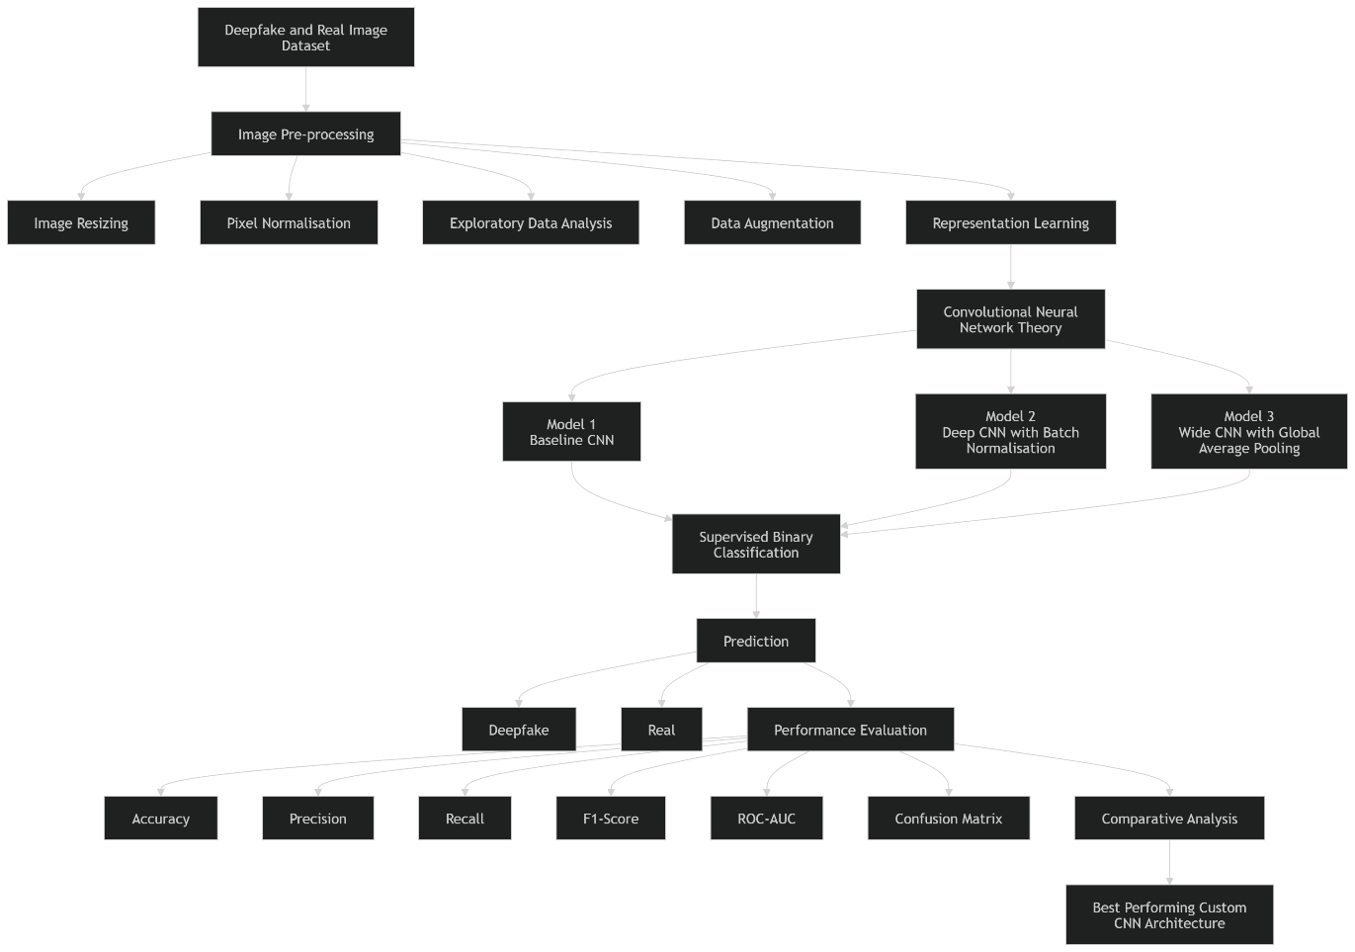
Figure 1: Theoretical Framework

2.7 Research Gap
Despite recent progress in deep fake image detection via deep learning methods, there are still some significant gaps in the research. Firstly, the existing research works are mainly concerned with the problem of detection accuracy, and relatively little attention has been paid to the efficiency of calculation and the deployment in practice. The methods for producing deepfakes are becoming more sophisticated, and many detection systems are becoming more complicated, making it difficult to implement them in real-time applications and resource-poor settings (Ayub et al., 2025; Amerini et al., 2025).
Second, most of the recent studies are based on transfer learning and hybrid deep learning architectures using pre-trained models like ResNet, EfficientNet, DenseNet, and so on. While these models have achieved excellent classification performance, they require considerable computational resources, extensive training time, and high memory consumption (Zhang et al., 2025; Potluri et al., 2026). In comparison, relatively few studies have been designed and tested custom CNNs that are entirely built from scratch by the author(s) with the same set of experimental conditions (Panigrahi, Mishra & Samal, 2025; Sharma, Garg & Caudron, 2024).
Lastly, the existing comparative studies include features such as datasets, preprocessing techniques, evaluation metrics, and experimental setups, which can vary, making it challenging to compare different CNN architectures fairly (Sunil et al., 2025; Raza et al., 2026). Thus, there is an obvious need for research that will enable the creation of several lightweight custom CNN designs with a common preprocessing strategy and the same evaluation methodology.

Chapter 3: Research Methodology

3.1 Research Design
The study was of quantitative and experimental technical research design that aimed at finding out the effectiveness of custom Convolutional Neural Network (CNN) architecture on deepfake image detection. For this reason, a quantitative approach was found to be the best choice for the study, as multiple CNN models are evaluated and compared quantitatively based on numerical evaluation metrics, such as accuracy, precision, recall, F1-score and Receiver Operating Characteristic-Area under the Curve (ROC-AUC) (Amerini et al., 2025). With the experimental design, three different CNN architectures were independently designed and trained, tested and evaluated, and compared in this study under the same experimental conditions and without any bias, making the experimental results objective and reproducible.

3.2 Data Collection
This study employed a publicly available secondary dataset, provided by Hugging Face Hub, "JamieWithofs/Deepfake-and-real-images. The data consists of labeled images that are part of two classes: deepfake (label 0) and real (label 1). For handling the computations and for having representative data, subsets were extracted from the original data set consisting of 6,000 training images, 1,200 validation images and 1,200 testing images. Before building models, the data set was scrutinized to ensure proper class distribution, image size, image format and missing labels.
Dataset link:
https://huggingface.co/datasets/JamieWithofs/Deepfake-and-real-images-validation/tree/main

3.3 Data Pre-processing and Exploratory Data Analysis
All images were transformed from PIL objects to RGB NumPy arrays and cropped to a common 64 × 64 size to train the CNN. The pixel values were then re-scaled to the range [0,1] to help with the stability of the optimisation process during training of the neural network. Each image label has been refitted into a binary vector that can be used in conjunction with a sigmoid activation function and a binary cross-entropy loss function (Jahan et al., 2026).
Exploratory Data Analysis (EDA) was performed to gain insights into the data prior to the development of the model. The analysis carried out in the study were: class distribution visualization, sample image inspection, pixel intensity histogram, average class image, comparison of RGB channels, image brightness distribution, split image distribution of the data set and channel-wise analysis of the pixel values. The visualizations helped in verifying the quality of the datasets and ensured that the data were adequate for classification using deep learning.

3.4 CNN Model Development
All the custom CNN architectures were designed and implemented from scratch using TensorFlow and Keras. The first model was a baseline architecture of three convolutional layers and max-pooling, a fully connected layer, a dropout layer, and a sigmoid output layer. The second architecture added an extra convolutional block and Batch Normalisation to enhance the stability in training. The third architecture is based on stacked convolutional layers followed by Global Average Pooling, which helped to keep the number of model parameters low and to avoid overfitting (Tiwari, 2025). The same preprocessing and training were used for all models to have a fair comparison, all models used Adam optimiser with learning rate 0.001, loss function was binary cross entropy, and models were trained for 10 epochs.

3.5 Model Evaluation
Model performance was evaluated using the unseen testing dataset. Several metrics were used for the evaluation, such as accuracy, precision, recall, F1-score, binary cross-entropy loss, confusion matrix, classification report, ROC curve, AUC, training time, and number of the parameters. Furthermore, accuracy and loss curves of training and validation were studied to understand the convergence behavior and check for overfitting (Qureshi et al., 2024). Then, a comparative analysis was carried out to find the best architecture of CNN in terms of predictive performance and computational efficiency.

3.6 Methodological Limitations
The methodology enables a controlled and systematic evaluation of custom CNN architectures, but there are some drawbacks that should be pointed out. First, the study was based on a subset and not the full set of data, and this may restrict the generalisability of the model. Secondly, only binary image classification, not multiclass forgery detection, was studied. Third, the models were trained for ten epochs under fixed hyper-parameters without any in-depth optimization.

Chapter 4: Artefact Design and Development

4.1 Artefact Overview
The artefact developed in this project is a deepfake image detection system based on Convolutional Neural Networks (CNNs) for binary classification of images as either deepfake or real. The system is composed of three unique CNN architectures built de novo, which represent the innovative aspect of the present work as compared to a number of previous studies that take advantage of transfer learning.

4.2 System Design and Development
This system was designed as a sequential deep learning pipeline, comprising of data collection, image preprocessing, data augmentation, CNN model development, evaluation of the developed models, and comparative analysis. Images were taken from the JamieWithofs/Deepfake-and-real-images dataset, accessible from the Hugging Face Hub. All images were preprocessed to be RGB images, 64 × 64 pixels, normalised to the range 0–1, and prepared for supervised binary classification. Prior to model training, exploratory Data Analysis was performed to analyze the distributions of classes, characteristics of images, intensity of individual pixels, RGB channels, and consistency of the datasets. The training data was augmented by rotating, zooming, shifting the image to the horizontal, or flipping the image upside down, to improve generalisation and reduce overfitting.

4.3 Tools and Technologies
The artefact is developed in python programming language with TensorFlow (TF) version 2.20 and Keras in CNN development. Data was processed and visualised using NumPy, Pandas, Matplotlib and Seaborn packages and images were manipulated with Pillow (PIL). The Hugging Face Datasets library was used for loading the datasets and Scikit-learn for the evaluation metrics such as accuracy, precision, recall, F1-score, ROC-AUC, confusion matrices, and classification reports.

4.4 Implementation and Testing

4.4.1 Dataset Inspection and Validation
The inspection of the dataset verifies that all the records have a picture and a label (Fake or Real) associated with them. All pictures are RGB and have the same resolution of 256 x 256 pixels. The training data (2,983 fake; 3,017 real), validation data (582 fake; 618 real), and test data (587 fake; 613 real) are well balanced and without any missing labels, suggesting a clean and reliable dataset for CNN model training.
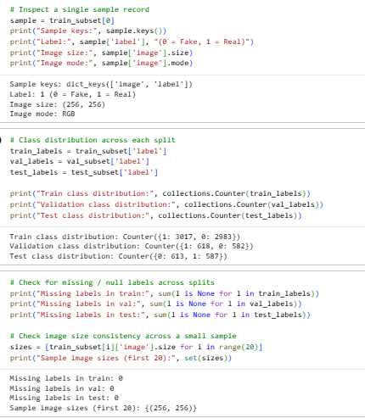
Figure 2: Dataset Inspection

4.4.2 Image Resizing and Training–Validation Data Preparation
The training and validation images were converted to RGB NumPy array and resized to 64 × 64 for CNN processing. The resulting datasets contained 6000 training images (shape: 6000 × 64 × 64 × 3) and 1200 validation images (shape: 1200 × 64 × 64 × 3), along with matching label vectors for supervised binary classification.
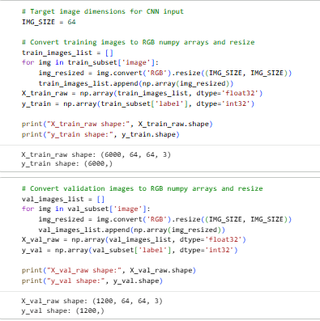
Figure 3: Data Preparation

4.4.3 Test Data Preparation and Pixel Value Inspection
The test data was also converted into RGB images of size 64 × 64 × 3 for the same consistency with training and validation datasets. The scale of the original image was confirmed by the values of the pixels after the image was normalised, ranging from 0 to 255, and the mean intensity was at 101.29, showing consistency of the original image used for the pre-processing of the CNN model.
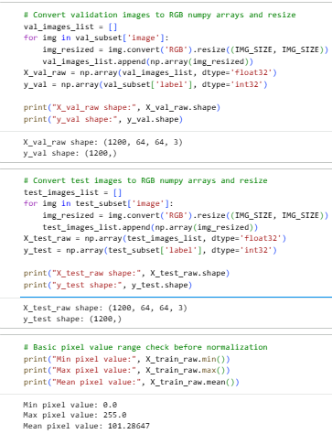
Figure 4:Test Data Preparation and Pixel Value Inspection

4.4.4 Class Distribution of the Training Dataset
The training set is well balanced with about 2,983 deepfake images and 3,017 real images. This nearly equal representation helps to avoid class imbalance effects, which makes it less likely that the model will be influenced by the majority class when training the model with the data, and allows the CNN to learn representative features from both classes, thus improving the classification performance of the CNN.
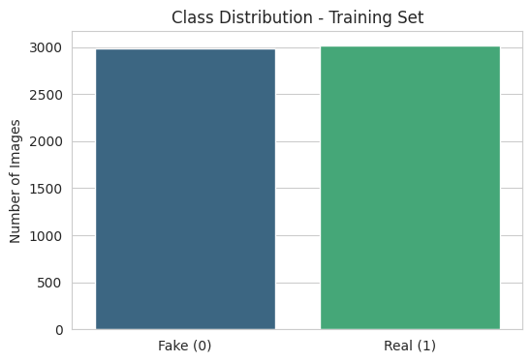
Figure 5:Class Distribution

4.4.5 Sample Images of Deepfake and Real Classes
The top line shows images from the two classes used for training the model, and the bottom line shows the deepfake images. Both classes are different in their facial appearance, lighting, pose and background indicating the diversity of the datasets and appropriate learning of a CNN model with robust and generalisable image features.
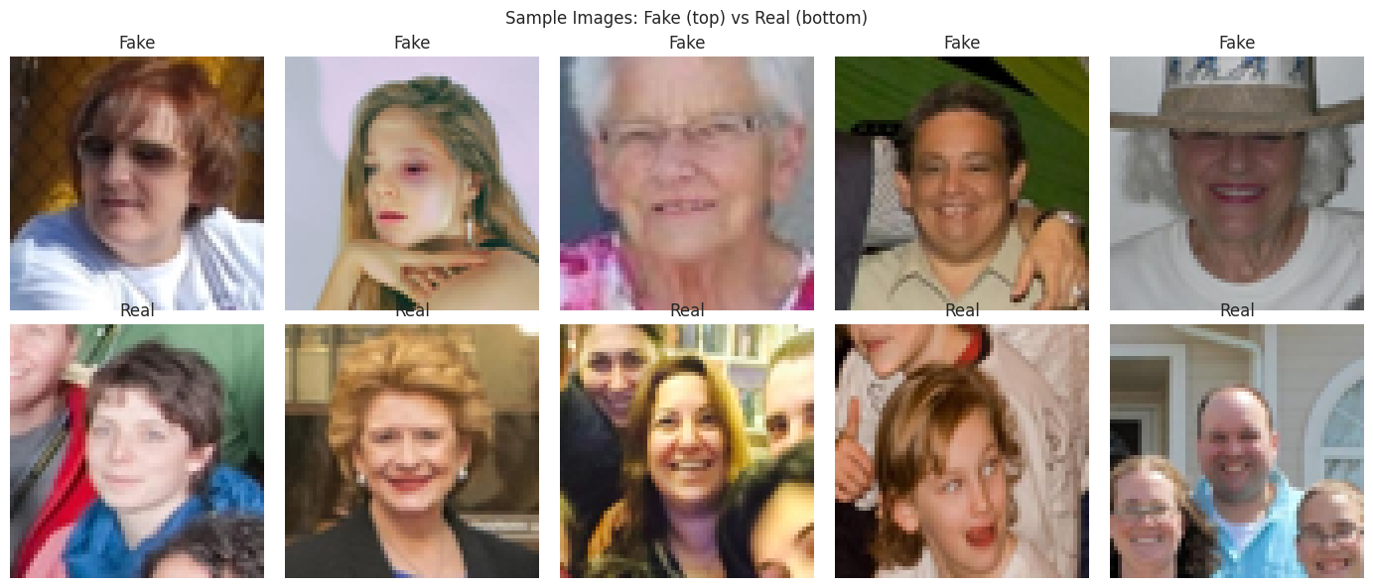
Figure 6:Sample Images

4.4.6 Overall Pixel Intensity Distribution
The histogram shows the distribution of intensity values for the pixels in the data set ranging from 0 to 255. Frequencies are higher at lower intensity values (around 20–40) and lower at higher intensity values. Frequencies are around 2.4 million pixels at lower intensity values and decrease at higher intensity values.
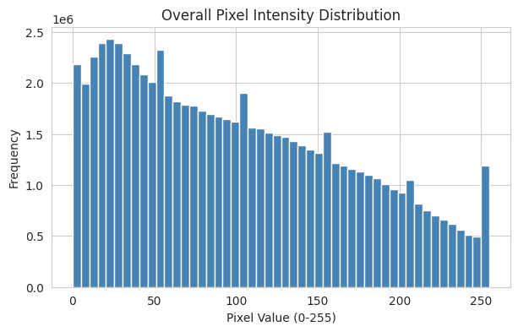
Figure 7: Overall Pixel Intensity Distribution

4.4.7 Average Deepfake and Real Images
The figure shows the mean (average) image which is computed separately for each image class (deepfake class and real class) by averaging all images in the training set of each class. The average images show similar facial structures and facial colour distributions, suggesting a consistent characteristic of the dataset.
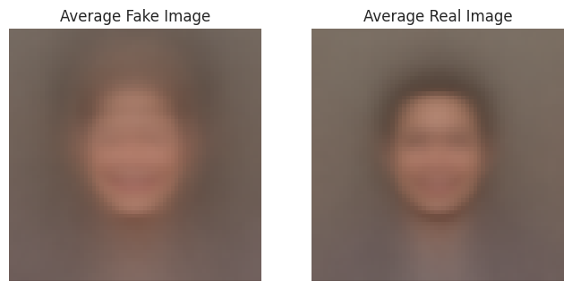
Figure 8:Average Deepfake and Real Images

4.4.8 Mean RGB Channel Values by Class
The figure shows the mean values of the Red, Green, and Blue (RGB) channels for the two classes of deepfake and real image. The colour distributions of both classes are similar with highest mean values in the Red channel (c. 118), highest mean values in the Green channel (c. 95–97) and highest mean values in the Blue channel (c. 85–88).
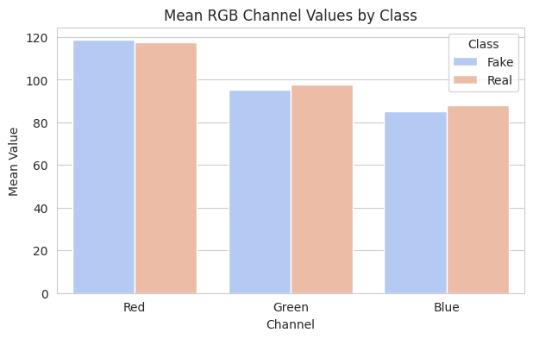
Figure 9:Mean RGB Channel Values by Class

4.4.9 Image Brightness Distribution by Class
The figure shows the average image brightness of deep fake and real classes. The distribution of both classes is approximately bell-shaped in which brightness values around 90-100 have the highest densities and densities are around 0.012. A significant degree of overlap suggests that the images are overall brighter in both classes, meaning overall brightness is not a good discriminator of deepfake images.
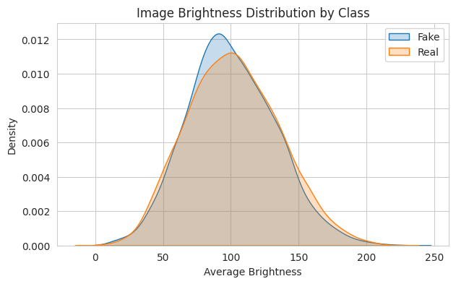
Figure 10:Image Brightness distribution by class

4.4.10 Class Distribution
The figure displays the distribution of deepfake (Fake) images in the training, validation and test sets. The training set has about 2983 fake images and 3017 real images, the validation set has 582 fake and 618 real images and the testing set has 587 fake and 613 real images.
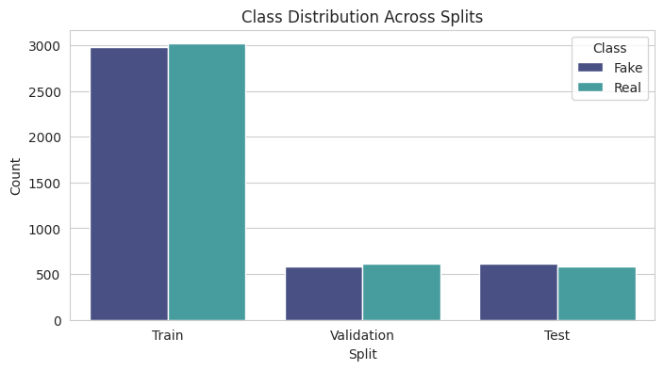
Figure 11:Class Distribution

4.4.11 Per-Channel Pixel Value Distribution
The figure shows the distribution of red, green and blue (RGB) pixels in a data set. The blue channel has the highest frequency for low pixel intensities (around 0-50) with nearly 1.0 million of those frequencies, and the red channel is the highest for high pixel intensities (150-255).
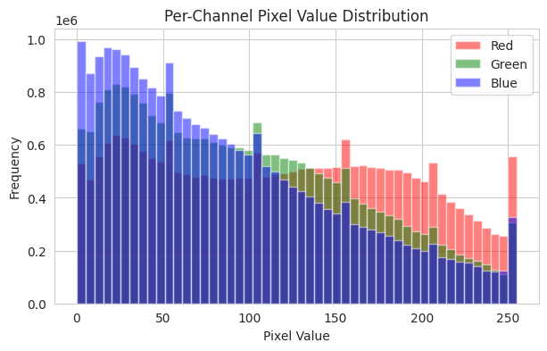
Figure 12: Per-Channel Pixel Value Distribution

4.4.12 Data Pre-processing and Feature Engineering
This figure shows the last two steps of preprocessing and feature engineering before training the CNN. The pixel values were scaled from the original range (0-255) to 0-1, which helped to improve the stability of training. The class labels were remodeled into (6000, 1), (1200, 1) and (1200, 1) for binary classification with a sigmoid output layer. Model robustness and the prevention of overfitting were obtained by data augmentation, which included 188 training batches of data with the input shape (64, 64,3) including 15° rotation, 10% width shifting, 10% height shifting, 10% zooming, and horizontal flipping.
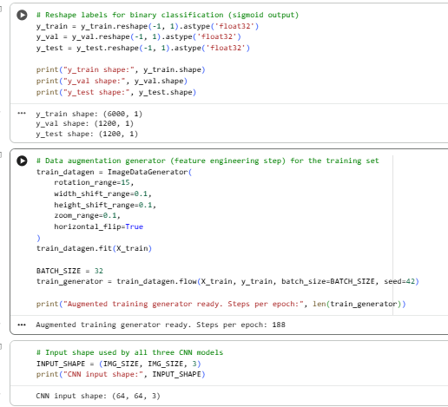
Figure 13: Data Pre-processing and Feature Engineering

4.4.13 Model Architecture
Model 1 – Baseline CNN Architecture
CNN is a baseline consisting of three convolutional layers, max-pooling, flattening, one dense layer, dropout, and sigmoid output. It has 1,142,081 trainable parameters and offers a simple and effective architecture to classify deepfake images into binary classes.
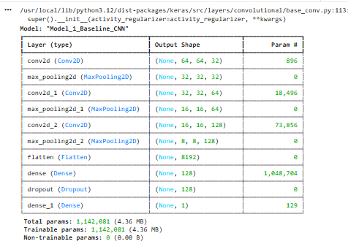
Figure 14: Model 1
Model 2 – Deep CNN with Batch Normalisation
Model 2 is simply the baseline with four convolutional layers after each convolutional layer, followed by Batch Normalisation. The architecture has 1,438,465 trainable parameters to enhance the feature extraction, training stability and classification performance.
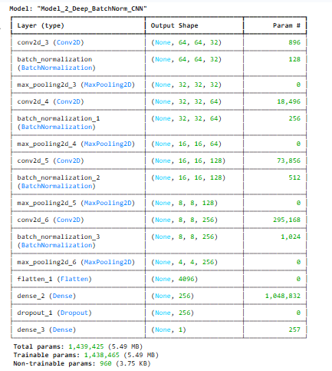
Figure 15: Model 2
Model 3 – Wide CNN with Global Average Pooling
In Model 3, instead of flattening there are multiple convolutional layers, dropout regularisation. It has 303,649 trainable parameters, which makes it a lightweight architecture that reduces the complexity while still achieving a good deepfake image classification performance.
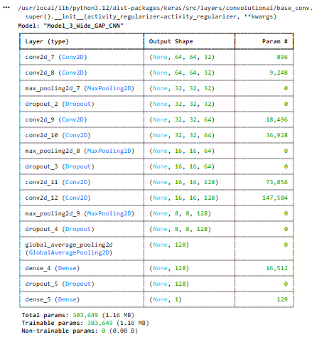
Figure 16:Model 3

Chapter 5: Project Management

5.1 Project Planning
The successful implementation of the deepfake image detection system was crucial to its completion within the given timeline and required effective project management. The project was conducted following a structured project lifecycle: project planning, literature review, dataset preparation, model development, model evaluation and report writing.

5.2 Project Implementation
The project was undertaken in phases. The first step was a thorough review of the literature to gain insights into the current state of the art in deepfake detection and pinpoint research gaps. This was followed by dataset acquisition, exploratory data analysis, and image preprocessing and data augmentation (Abdel-Wahab & Alkhatib, 2025). Design, implementation and training of three custom Convolutional Neural Network (CNN) architectures was the next step.

5.3 Risk Management
Risk | Impact | Mitigation
Poor data quality | High | Verify and clean dataset before training.
Computational limitations | High | Resize images and use a manageable dataset.
Model overfitting | High | Apply data augmentation and dropout.
Long training time | Medium | Use GPU and optimise training settings.
Poor model performance | High | Compare multiple CNN models using validation data.
Software errors | Medium | Perform regular testing and code validation.
Project delays | Medium | Follow project milestones and monitor progress.
Data loss | High | Maintain regular backups of code and data.

5.4 Challenges and Adaptations
There were some implementation problems identified. The higher the depth of the CNN, the more computational resources were needed and the longer it took to execute, and the higher the model complexity, the better classification performance was not necessarily achieved (Potluri et al., 2026). For resolving this problem, three different CNN architectures were evaluated on the same experimental setup.

5.5 Reflection on Project Management
The project was effectively managed, with structured planning, milestone tracking, regular review, and risk management, resulting in a successful outcome. This phased development allowed for each phase to be completed before moving on to the next, minimizing the risk of delays and enhancing project organization. While there were some challenges involving computation and model optimisation, these were overcome by a systematic approach to experimentation and comparison evaluations. As a result, the project met its research goals and developed a dependable and replicable deepfake image detection system.

Chapter 6: Evaluation and Discussion

6.1 Model Outcomes

6.1.1 CNN Model 1: Simple Baseline CNN
Model 1 had a test loss of 0.5085 and a test accuracy of 74.50%, which shows good classification results when validating the model on the test dataset. The model recorded precision of 69.22%, recall of 86.20%, and F1-score of 76.78%. It performed successfully in the classification of Real images (recall = 0.86) as compared to Fake images (recall = 0.63), so it shows reliable baseline performance.
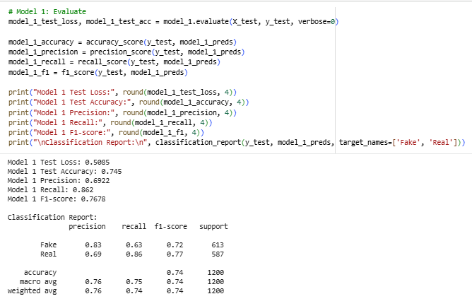
Figure 17: Model 1 evaluation
Model 1 Confusion Matrix
As evident in the confusion matrix, 388 Fake and 506 Real images were correctly classified. But, 225 Fake images were wrongly classified as Real, and 81 Real images were misclassified as Fake. The results show that the performance of model-1 is better with recognition of Real image than Fake image, resulting in a classification accuracy of 74.50%.
Model 1 Accuracy Curve
The accuracy of the model in training and validation sets increased steadily for 10 epochs, showing a stable learning behavior. The training accuracy rate rose from around 55% to 75% and the validation rate rose to around 77%. The validation curve was only slightly above the training curve, suggesting good generalisation and a lack of overfitting during model training.
Model 1 Loss Curve
The loss curves demonstrate that the model is optimised during training. The training loss was reduced from ~0.68 to 0.49, and the validation loss was reduced from ~0.68 to 0.48 over 10 epochs. Both curves are very close, indicating that the system is converging well, learning efficiently, and not overfitting during training.
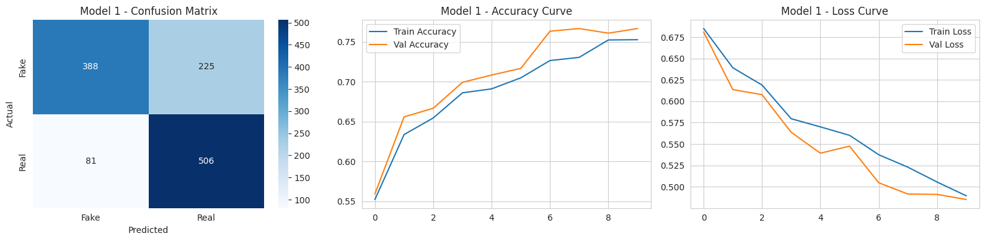
Figure 18: Model 1

6.1.2 CNN Model 2: Deeper CNN with Batch Normalization
Model 2 had a test loss of 0.7640 and test accuracy of 61.83%. The model recorded precision of 56.73%, recall of 92.67%, and an F1-score of 70.38%. The classification report reveals good small set detection of Real images (recall = 0.93), which is not as strong in Fake images (recall = 0.32).
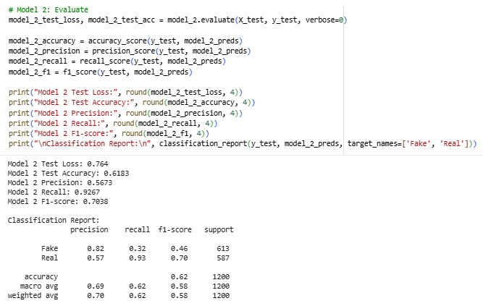
Figure 19: Model 2 evaluation
Model 2 Confusion Matrix
The confusion matrix depicts that 198 images of Fake class and 544 images of Real class were classified correctly. However, 415 Fake images were wrongly predicted as Real and 43 Real images were wrongly predicted as Fake. The results showed that the proposed model 2 has a strong preference to predict Real images with a moderate performance in the prediction of Fake images.
Model 2 Accuracy Curve
The accuracy on training set climbed steadily over 10 epochs from around 60% to 82% while the accuracy on the validation set ranged between 51% and 77% and then dropped to about 69%. There is a significant difference between the accuracy of the training set and the validation set, indicating that model 2 is overfitting and does not generalise well to new data.
Model 2 Loss Curve
The training loss always reduced from around 0.84 to 0.40, reflecting the optimalisation during the learning process. The validation loss, however, was highly variable and started low then peaked up to around 0.65. This pattern of instability in the test set indicates overfitting and decreasing model stability, which leads to weaker classification accuracy when applying the model to the test set.
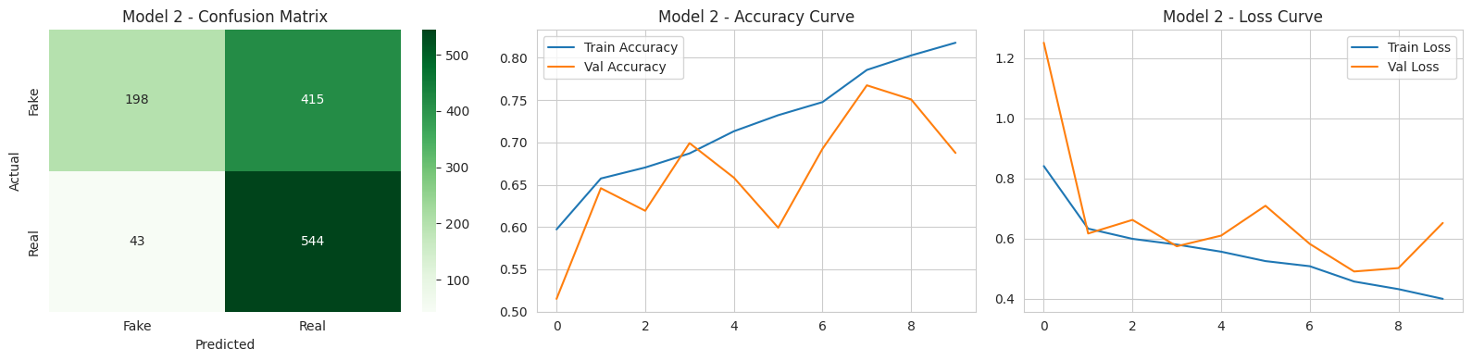
Figure 20: Model 2

6.1.3 CNN Model 3: Wide CNN with Global Average Pooling
The model 3 lost 0.6936 and had 48.92% accuracy in its test set which shows poor classification performance. The model recorded precision of 48.92%, recall of 100%, and an F1-score of 65.70%. The classification report reveals that the model is able to classify only Real images and not any fake images, yielding a weak performance.
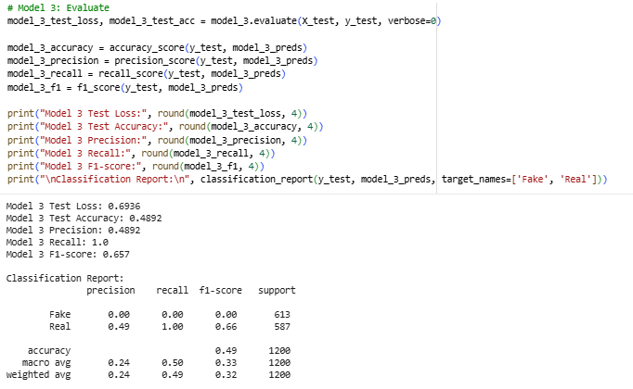
Figure 21: Model 3 evaluation
Model 3 Confusion Matrix
As seen in the confusion matrix, all 613 Fake images were misclassified as Real and all 587 Real images were correctly classified. The result of the model was that 0 predictions were correct for the Fake class and 587 predictions were correct for the Real class, showing a strong bias in model predictions towards the Real class.
Model 3 Accuracy Curve
The accuracy of the training and the validation set did not change significantly throughout the 10 epochs used for training, ranging from 49% to 52%. Since no noticeable improvement can be seen this means that model doesn't learn meaningful discriminative features from the data set. This sub-optimal learning behaviour implies underfitting in learning and hence, poor generalising and limited classification ability.
Model 3 Loss Curve
The training and validation loss curves did not show significant changes, hugging around 0.693, over the 10 epochs. This loss value does not change over time, suggesting that little happened in the optimisation process while training. The loss is high and remains stable, indicating that the model is underfitting the data, which can be due to insufficient training.The loss is high and stable, suggesting that the model is not learning well and is underfit, meaning it is not performing well.
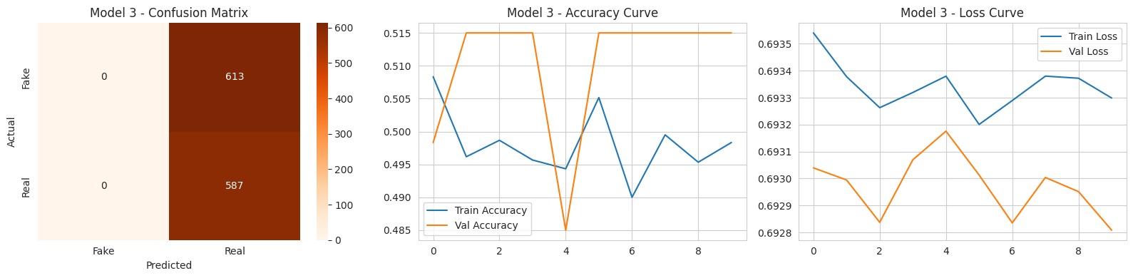
Figure 22: Model 3

6.2 Model Performance Comparison
From the comparison table, it can be seen that the test accuracy, precision, and F1 score obtained by Model 1 is the highest, so it is the best model. The model 2 achieved the highest recall (92.67%) and the highest accuracy (61.83%), while the model 3 had the lowest accuracy (48.92%) and recall (67.87%) due to its lower classification ability although the number of its parameters is the lowest.
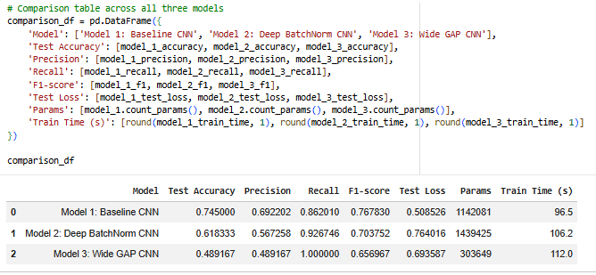
Figure 23: Model Performance Comparison

6.3 Classification Metrics Comparison
The bar chart is used to show the comparison of the classification metrics of all three CNN models. Model 1 had the best accuracy, precision and F1 score, and Model 2 had the highest recall. Although Model 3 had 100% recall, it did not do well in most of the other metrics, thus demonstrating that Model 1 is the best overall tradeoff of reliability and classification performance.
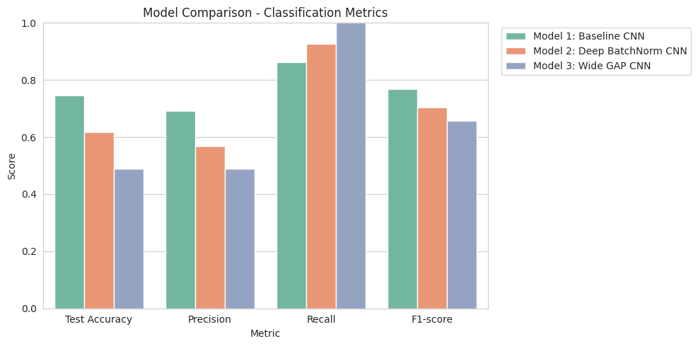
Figure 24: Classification Metrics Comparison

6.4 Validation Accuracy Comparison across Models
The curves for validation accuracy show that the Model 1 improved the most consistently and steadily, with validation accuracy of around 77%. The validation performance of model 2 was unstable and had some fluctuations indicating overfitting. Model 3 did not change much in its performance around 51% showing that it had poor learning capability and poor generalisation throughout the training process.
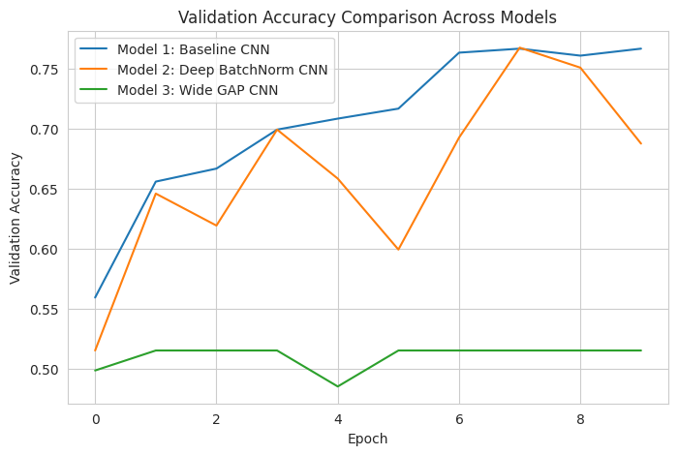
Figure 25: Validation Accuracy Comparison

6.5 ROC Curve Comparison
The ROC curves show that model 1 had the best AUC of 0.834 with the best discrimination between deepfake and real images. For model 2, the AUC was 0.782, which indicated moderate performance. Model 3 had an AUC of 0.500 (random guess), indicating that it was not able to discriminate between the two classes very well.
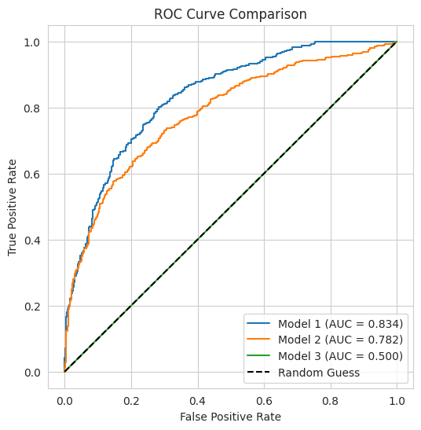
Figure 26: ROC Curve Comparison

6.6 Best-Performing Model Selection
The comparison results showed that Model 1 (Baseline CNN) was the most successful architecture. It attained the maximum test accuracy of 74.50% and an F1-score of 76.78%, which is better than the other two CNN models. The results show that the baseline architecture achieves the highest accuracy, precision, recall, and highest overall classification accuracy.
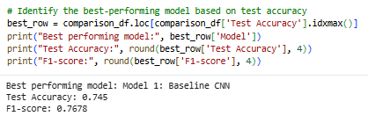
Figure 27: Best-Performing Model

6.7 Sample Predictions Using the Best Model
The sample prediction results show what the Model 1 does with new test images. All the 5 images displayed were correctly classified with the Real image classified as Real and the Fake image classified as Fake. The examples show the accuracy of the model in practical tests distinguishing between real and manipulated facial images.
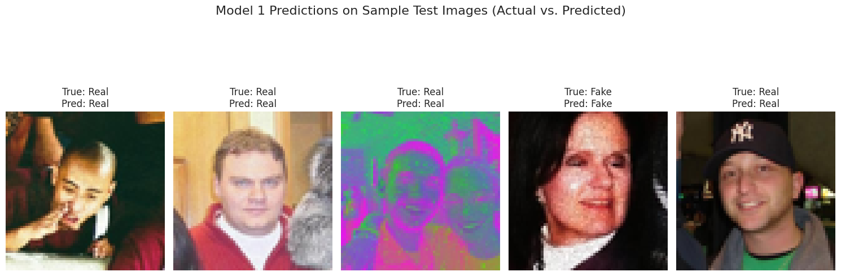
Figure 28: Sample Predictions

6.8 Discussion
The systematic design, implementation and evaluation of three custom Convolutional Neural Network (CNN) architectures for deepfake image detection was performed successfully, resulting in the accomplishment of all the proposed research objectives. The first goal was achieved by conducting an extensive literature review, which revealed the increasing difficulty of deepfakes created by AI and the drawbacks of current transfer learning methods for detection, such as their complexity and restrictions on implementation. This review identified the motivation for developing lightweight CNN models from the scratch.
The second goal was accomplished through a thorough Exploratory Data Analysis (EDA) of the chosen Hugging Face dataset. Balanced class distributions were verified through dataset inspection, pixel intensity analysis, comparison of RGB channel intensity, use of brightness distributions, and sample image visualisations to aid understanding of the dataset characteristics. Moreover, image resizing, normalisation and data augmentation improved the quality and diversity of training data.
The third goal was achieved by creating three custom CNN architectures using TensorFlow and Keras without the use of pre-trained models. Each of the architectures presented had added structural features that allowed the performance to be compared under the same pre-processing, training, and evaluation settings. Thirdly, the fourth objective was fulfilled by performing comprehensive performance evaluation with accuracy, precision, recall, F1-score, confusion matrix, ROC curve, validation curve, computational complexity, and training time. The three architectures tested, with Model 1 (Baseline CNN) showing the highest test accuracy (74.50%) and F1 score (76.78%), and an AUC of 0.834, were the least complex of the three deep architectures. The results show that such a well-designed custom CNN can be a feasible and effective solution for binary deepfake image detection without the use of the expensive transfer learning models.

Chapter 7: Legal, ethical and social issues
There are several legal, ethical, professional and social dimensions to consider in the development of an Artificial Intelligence (AI) based deepfake image detection system that need to be taken into account during the life cycle of the project. This study employed a publicly accessible secondary data set from the Hugging Face Hub from a legal perspective. The researcher did not collect personal data because this dataset was freely available and it was not necessary to interact directly with the human subjects. The project adhered to the licensing requirements of the dataset and made sure to properly credit the source of the dataset and academic references. As a result, formal human research approval was not needed due to the lack of identifiable personal information and primary data collection.
The project was executed ethically, adhering to principles of integrity, transparency, honesty, and responsible AI research. The trained CNN models were only for research purposes or cybersecurity and not for surveillance or misuse. All the phases of the research from data preprocessing, model building, validation and reporting were documented in transparent and reproducible manner. Algorithmic bias was taken into account due to the possibility that a deepfake dataset may not be balanced by demographics. The dataset provided was fairly balanced between fake and real images but further considerations are needed for model generalisation for gender, ethnicity and age aspects to enhance fairness.
Professionally, the project is in line with responsible computing by adhering to recognised software engineering principles, reproducible experimental procedures and with accurate reporting of strengths and limitations of the developed models. The research did not overestimate the performance of the models and admitted that the suggested CNN architectures need more testing with wider sets of data.
From a societal perspective, reliable deepfake detection systems have become increasingly important due to the rapid growth of AI-generated synthetic media. Digital forensics, cybersecurity, journalism, law enforcement and social media can all benefit from the use of effective detection models to help identify manipulated content, minimize misinformation, safeguard individual identities and build public confidence in digital media. This study thus helps to address the ethical dimensions of automated decision-making systems and plays a role in the responsible development of AI technologies aiming at ensuring cybersecurity resilience and digital authenticity.

Chapter 8: Conclusion and Recommendations
The project succeeded in designing, training and comparatively evaluating three custom Convolutional Neural Network (CNN) architectures for binary deepfake image detection, as the main objective. Through a thorough literature study, the challenges of deepfake images created by AI systems were identified and it was pointed out that the deep learning transfer learning approaches suffer from a high computational burden. Data processing was carried out according to the following stages: system preprocessing, exploratory data analysis and data augmentation of the selected data set prior to the development of the model. To make a fair comparison, three CNN architectures were designed from scratch and tested under the same set of experimental conditions.
Overall, the proposed Model 1 (Baseline CNN) achieved the highest test accuracy of 74.50%, precision of 69.22%, recall of 86.20%, F1-score of 76.78% and an AUC of 0.834 among the proposed architectures. The results showed that Model 2 achieved high recall rates while also making a number of errors in recognising fake images, indicating a lack of generalisation; Model 3, however, exhibited a high degree of underfitting, with poor results across all image-recognition tasks. The results prove that lightweight CNN design can be very efficient for detecting fake images in a deepfake video, without using a pre-trained model that requires a large number of computations.
During the project several technical and research skills have been acquired such as the creation of deep learning models, exploratory data analysis, image preprocessing, implementation in TensorFlow and Keras, experimental evaluation, comparison of models and writing of scientific reports. The project also enhanced problem-solving skills, critical analysis and project management skills.
Although it has been successful, there are a number of limitations. The models were trained using a subset of one publicly available data set with fixed hyper parameters and binary classification. Future work should employ larger and more varied datasets to assess the proposed architectures, explore multiclass deepfake classification and consider the optimisation of hyperparameters using automated methods, and the integration of explainable AI techniques such as Grad-CAM or SHAP for enhancing model interpretability. In addition, employing attention mechanism, transformer-based architectures or light-weight hybrid CNN models could further boost the accuracy of the detection while preserving the computational efficiency. The improvements would make these deepfake detection systems more useful in real-world cyber security and digital forensic scenarios.

References
Abdel-Wahab, A., & Alkhatib, M. (2025). Toward robust deepfake defense: A review of deepfake detection and prevention techniques in images. Computers, Materials & Continua, 86(2), 1–34. https://doi.org/10.32604/cmc.2025.070010
AbdulQudus, A. B., Amodu, O. A., Bukar, U. A., Mahmood, R. A. R., Zakaria, A. F., Queen, S.-O., & Hanapi, Z. M. (2025). A contemporary and comprehensive bibliometric exposition on deepfake research and trends. Computers, Materials & Continua, 84(1), 153–236. https://doi.org/10.32604/cmc.2025.061427
Ahmad, H., Sarwar, M. A., Khan, A. N., Alvi, A., Riaz, U., Khawaja, L., Mudassar, M. A., Ahmad, A., TAF, I., & Khan, W. Z. (2025). Unified intelligence: A comprehensive review of the synergy between data science, artificial intelligence, and machine learning in the age of big data. Scholars Journal of Engineering and Technology, 13(8), 585–617. https://doi.org/10.36347/sjet.2025.v13i08.001
Ahmad, P. N., Shah, A. M., & Lee, K. (2025). Enhanced propaganda detection in public social media discussions using a fine-tuned deep learning model: A diffusion of innovation perspective. Future Internet, 17(5), Article 212. https://doi.org/10.3390/fi17050212
Alharthi, R., Ojo, S., Nathaniel, T. I., Samee, N. A., Umer, M., Jamjoom, M. M., Alsubai, S., & Khan, J. (2025). Responsible detection and mitigation of AI-generated text using hybrid neural networks and feature fusion: Toward trustworthy content management in the era of large language models. International Journal of Computational Intelligence Systems, 18(1). https://doi.org/10.1007/s44196-025-01025-w
Amerini, I., Barni, M., Battiato, S., Bestagini, P., Boato, G., Bruni, V., Caldelli, R., De Natale, F., De Nicola, R., Guarnera, L., Mandelli, S., Majid, T., Marcialis, G. L., Micheletto, M., Montibeller, A., Orrù, G., Ortis, A., Perazzo, P., Puglisi, G., & Vitulano, D. (2025). Deepfake media forensics: Status and future challenges. Journal of Imaging, 11(3), Article 73. https://doi.org/10.3390/jimaging11030073
Ayub, K. A., Ali, L. A., Azeem, I. S., Sajid, U., Muhammad, S., & Syed, D. (2025). A survey on multimedia-enabled deepfake detection: State-of-the-art tools and techniques, emerging trends, current challenges & limitations, and future directions. Discover Computing, 28(1), Article 48. https://doi.org/10.1007/s10791-025-09550-0
Babaei, R., Cheng, S., Duan, R., & Zhao, S. (2025). Generative artificial intelligence and the evolving challenge of deepfake detection: A systematic analysis. Journal of Sensor and Actuator Networks, 14(1), Article 17. https://doi.org/10.3390/jsan14010017
Dharma, E. M., Iswari, N. M. S., & Arimbawa, I. P. R. A. (2025). Deepfake image detection using Convolutional Neural Network with EfficientNet architecture. G-Tech: Jurnal Teknologi Terapan, 9(4), 1829–1838. https://doi.org/10.70609/g-tech.v9i4.7727
Haider, R., & Pearl, J. (2024). AI-driven cyber forensics: Investigating cyber crimes and strengthening multi-factor authentication in digital environments. ResearchGate. https://doi.org/10.13140/RG.2.2.15715.77607
Hynek, N., Gavurova, B., & Kubak, M. (2025). Risks and benefits of artificial intelligence deepfakes: Systematic review and comparison of public attitudes in seven European countries. Journal of Innovation & Knowledge, 10(5), Article 100782. https://doi.org/10.1016/j.jik.2025.100782
Jahan, F., Shifat, S. M., Morol, M. K., Fahad, N., Goh, K. O. M., Nandi, D., Abdullah-Al-Jubair, M., & Hossen, M. J. (2026). Generative AI and the rise of deepfake technology: A journey from traditional techniques to LLM integration. Discover Applied Sciences, 8(5). https://doi.org/10.1007/s42452-026-08402-w
Javed, M., Zhang, Z., Dahri, F. H., Laghari, A. A., Krajčík, M., & Almadhor, A. (2025). Audio–visual synchronization and lip movement analysis for real-time deepfake detection. International Journal of Computational Intelligence Systems, 18(1). https://doi.org/10.1007/s44196-025-00911-7
Kumar, B. A., Misra, N. K., Pathak, N., Ahmadpour, S.-S., Krishnamoorthy, M., Shukla, D. K., Patidar, M., & Hakimi, M. (2025). Hybrid CMNV2: Deepfake faces classification and recognition using deep learning methods. Results in Engineering, 28, Article 107513. https://doi.org/10.1016/j.rineng.2025.107513
Morankar, G., Tripathi, R., Dhanore, S., & Tiwari, Y. (2025). Deepfake image detection using Convolutional Neural Network. In Advances in intelligent systems and computing (pp. 51–62). Springer. https://doi.org/10.1007/978-981-96-1981-8_5
Panigrahi, B. K., Mishra, S. P., & Samal, C. K. (2025). Deepfake detection using deep learning: A review. Advances in Research, 26(4), 555–564. https://doi.org/10.9734/air/2025/v26i41435
Potluri, S., Kandagatla, S. P., Mohanty, S. N., Rout, K. C., Israr, M., & Gupta, V. M. (2026). Hybrid deep feature integration model for robust deepfake detection using transfer-learned neural networks. Frontiers in Artificial Intelligence, 9, Article 1737761. https://doi.org/10.3389/frai.2026.1737761
Qureshi, S. M., Saeed, A., Almotiri, S. H., Ahmad, F., & Al Ghamdi, M. A. (2024). Deepfake forensics: A survey of digital forensic methods for multimodal deepfake identification on social media. PeerJ Computer Science, 10, e2037. https://doi.org/10.7717/peerj-cs.2037
Raza, A., Basit, A., Amin, A., Arfeen, Z. A., Masud, M. I., Fayyaz, U., & Jumani, T. A. (2026). A comprehensive review of deepfake detection techniques: From traditional machine learning to advanced deep learning architectures. AI, 7(2), Article 68. https://doi.org/10.3390/ai7020068
Sadiq, S., Ullah, S., Abuzinadah, N., Alharthi, R., Alabdullah, B., Umer, M., Alsubai, S., & Kryvinska, N. (2026). DEFT-Net: Explainable deepfake text detection for combating information disorder in the age of generative AI. International Journal of Computational Intelligence Systems, 19(1). https://doi.org/10.1007/s44196-026-01192-4
Sardhara, A., Vekariya, V., Pathak, A. R., & Dash, S. (2026). DeepForgeryNet: A hybrid CNN–LSTM and transfer learning framework for robust image forgery and deepfake detection. Frontiers in Artificial Intelligence, 9, Article 1810912. https://doi.org/10.3389/frai.2026.1810912
Sharma, V. K., Garg, R., & Caudron, Q. (2025). A systematic literature review on deepfake detection techniques. Multimedia Tools and Applications, 84(20), 22187–22229. https://doi.org/10.1007/s11042-024-19906-1
Sheikh, M., Tariq, M., Farrukh, M., & Salman, A. (2026). Deepfake dilemma: A profound threat to trust and authenticity in media and society. Journal of Social Sciences Research Perspectives, 4(2), 66–79. https://doi.org/10.71327/jssrp.42.66.79
Sunil, R., Mer, P., Diwan, A., Mahadeva, R., & Sharma, A. (2025). Exploring autonomous methods for deepfake detection: A detailed survey on techniques and evaluation. Heliyon, 11(3), Article e42273. https://doi.org/10.1016/j.heliyon.2025.e42273
Tiwari, S. (2025). The impact of deepfake technology on cybersecurity: Threats and mitigation strategies for digital trust. SSRN Electronic Journal. https://doi.org/10.2139/ssrn.5259359
Zhang, Y., Pang, Z., Huang, S., Wang, C., & Zhou, X. (2025). Unmasking AI-created visual content: A review of generated images and deepfake detection technologies. Journal of King Saud University Computer and Information Sciences, 37(6), Article 148. https://doi.org/10.1007/s44443-025-00154-8

